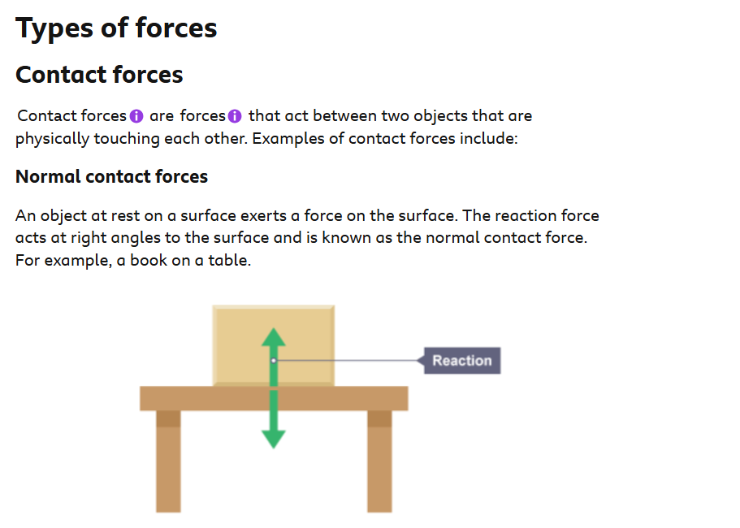

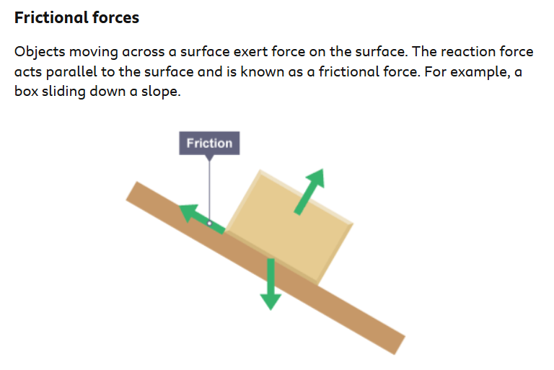

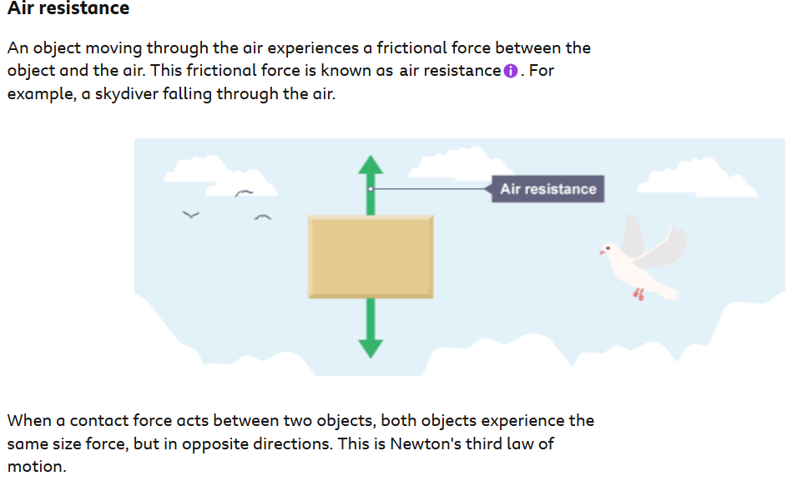



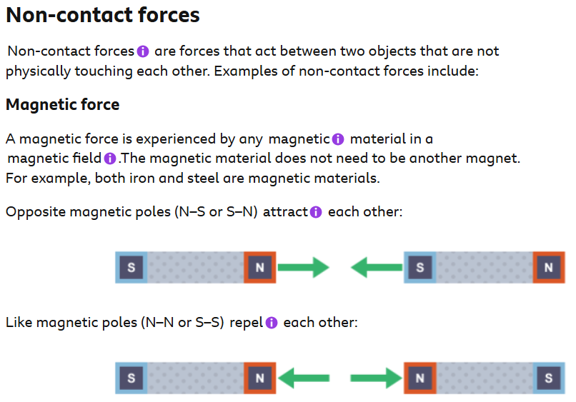

Opposite magnetic poles (N-S or S-N) attract each other:

Like magnetic poles (N-N or S-S) repel each other:

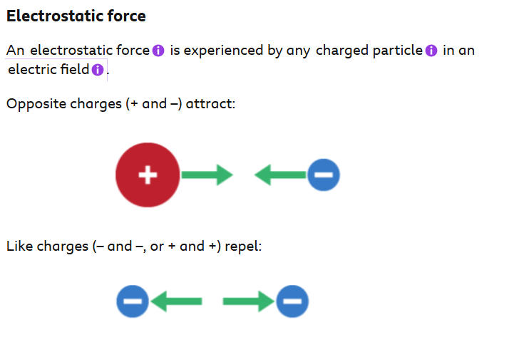
Electrostatic force: A force of attraction between particles with opposite charges.
Charged particle: Particles, usually ions or electrons, that carry electrical charges.
Electric field: Area surrounding an electric charge that may influence other charged particles.

